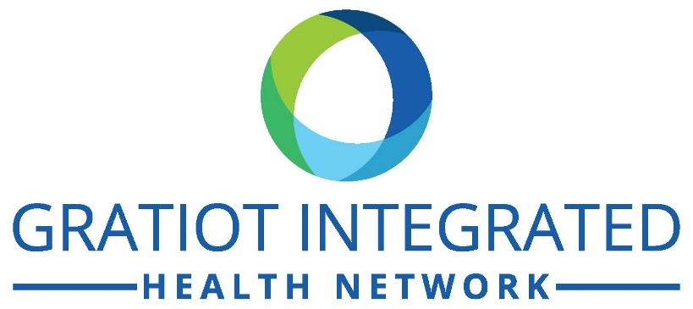 | GRATIOT INTEGRATED HEALTH NETWORK  BOARD OF DIRECTORS  Regular Board Meetings at 5:30 P.M.  On Second Thursday of the Month – Unless noted.  Location: Eagle Conference Room – Gratiot Integrated Health Network.  608 Wright Avenue, Alma, MI 48801  (989)-463-4971  Option to attend meeting via Zoom – current link/meeting information can be found on Facebook or by contacting Executive Assistant – Melissa Guthrie at mguthrie@gihn-mi.org or 989-466-4145.
Meeting Date 2021  October 14th, 2021  November 11th, 2021  December 9th, 2021 | Meeting Date 2022  January 13th, 2022  February 10th, 2022  March 10th, 2022  April 14th, 2022  May 12th, 2022  June 9th, 2022  July 14th, 2022  August 11th, 2022  September 8th, 2022  October 13th, 2022  November 10th, 2022  December 8th, 2022
Posted Pursuant to PA27 of 1976, Section 4 (a-d)
ALL MEETINGS ARE OPEN TO THE PUBLIC.

